Create a Python-Selenium Script of performing a search on duckduckgo.com and going to the first search link

Install selenium by the following command.

After installing, download the Chromedriver. Make sure to use latest version.

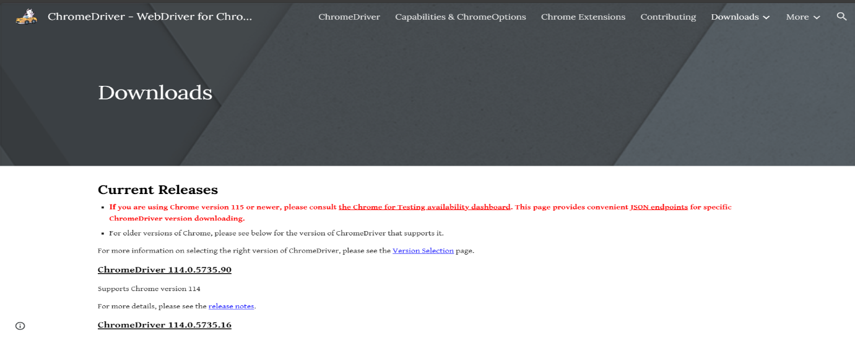

Download the win32.zip file for windows.

After downloading, go to chrome browser and update to latest version.

Go to Environment Variables .

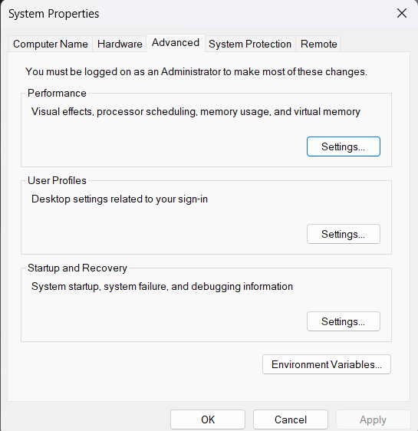

Copy the path of the chromedriver and edit the environment variables and choose OK. Make sure to add in both user and system settings.

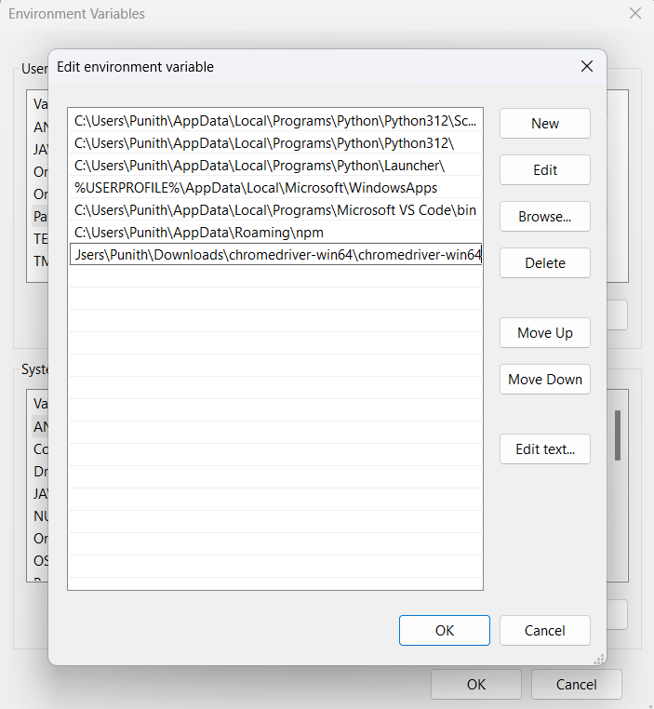

This is the python code with selenium. This code first navigates to duckduckgo.com and searches “What is DevOps” and clicks on the first page that appears on the browser. Run the file.

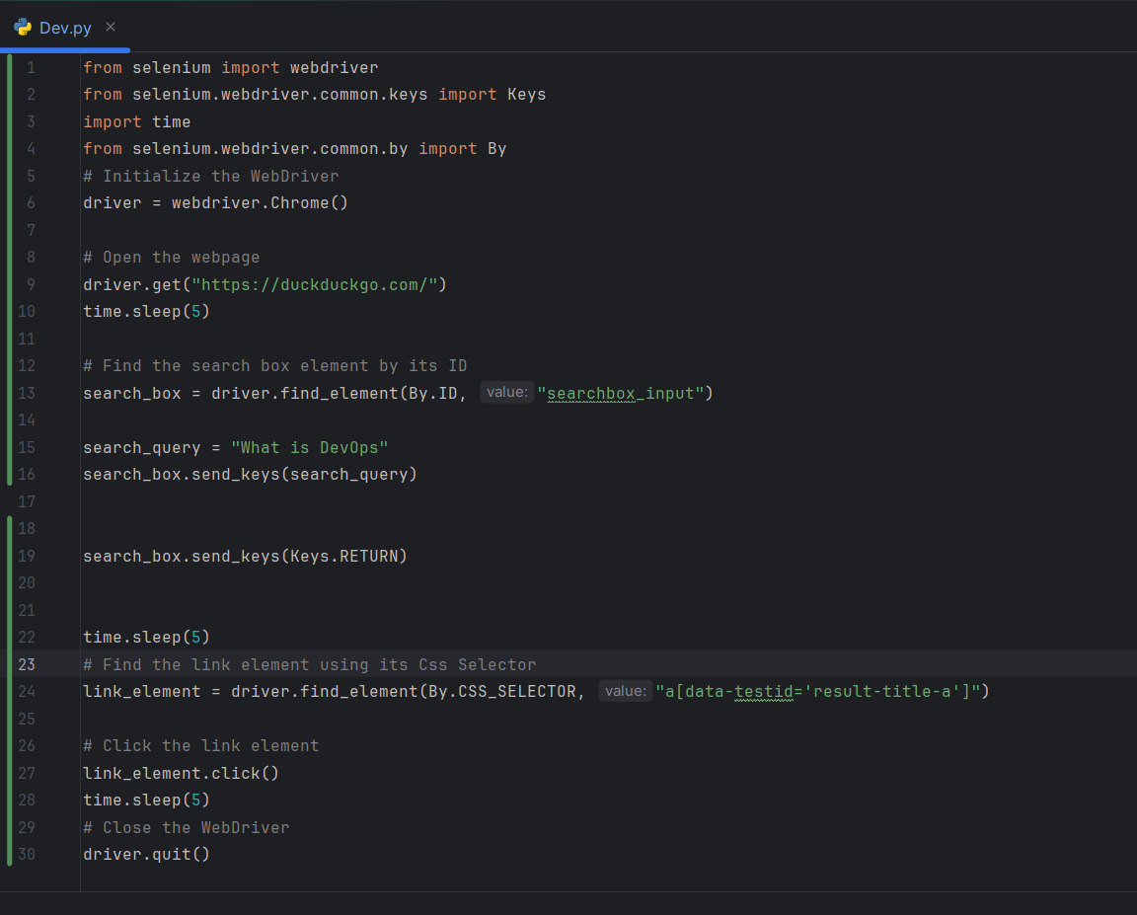

First it opens the duckduckgo.com and waits for 5seconds.

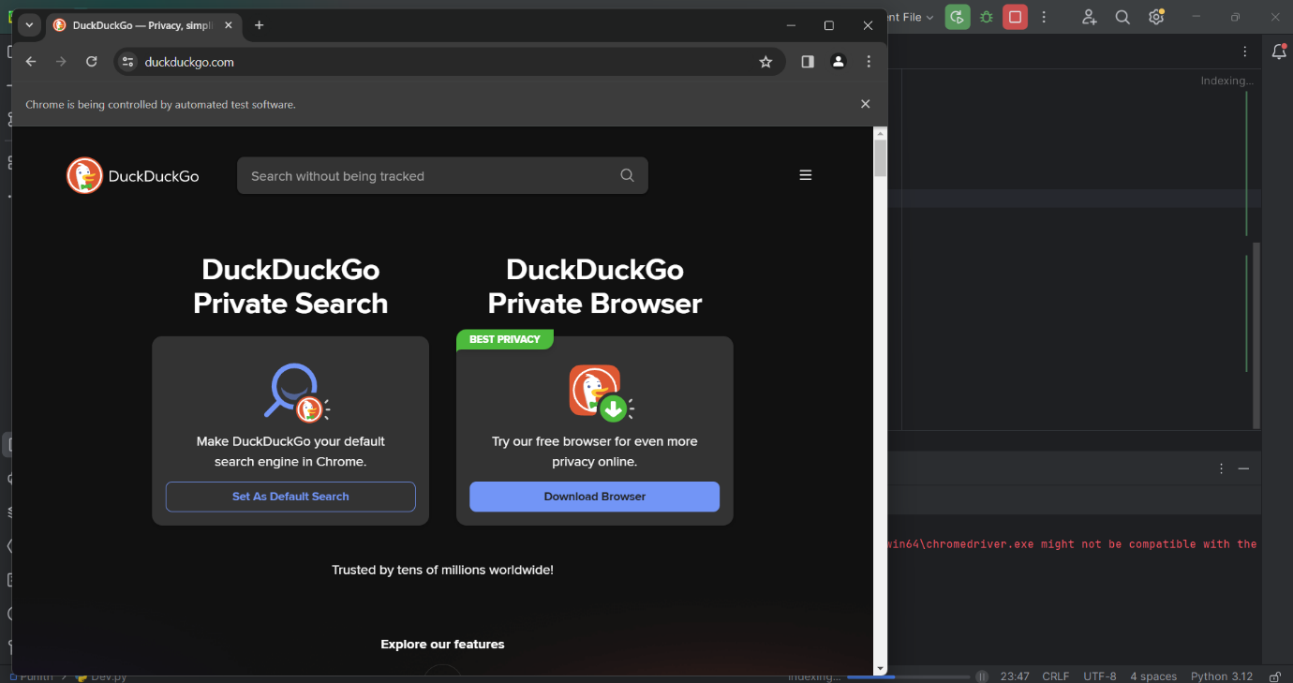

Enters the text in the searchbar.

After searching for “What is DevOps”, then it again waits for 5seconds and clicks on the first page that appears.

This is the first page that came and it explains about DevOps.

